**Content for COVID 19 Center app**

1. **Splash Screen**

Following details should display.

Logo

App title : TSR Heart Care & Diagnostics

Our details :- Developed by Dwaipayana Technologies, Bengaluru

**Design reference :-**

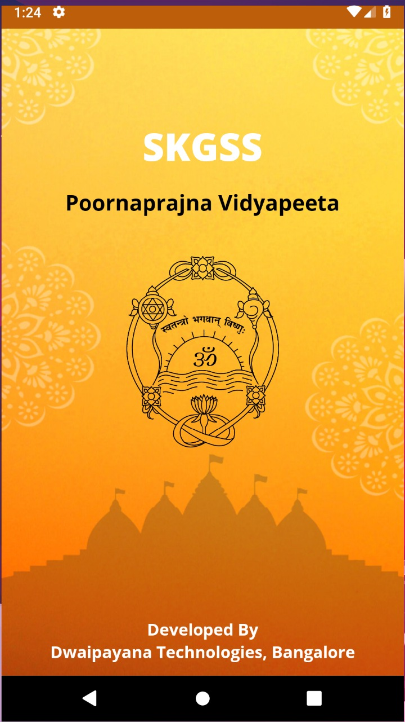

2.  **Sign up page :-**

Name

Gender

House/Flat number

Ward number

Street details

Landmark (optional)

Area name (optional)

Mobile number

Password

Confirm password

Terms & Conditions (Check box)

**Design reference :-**

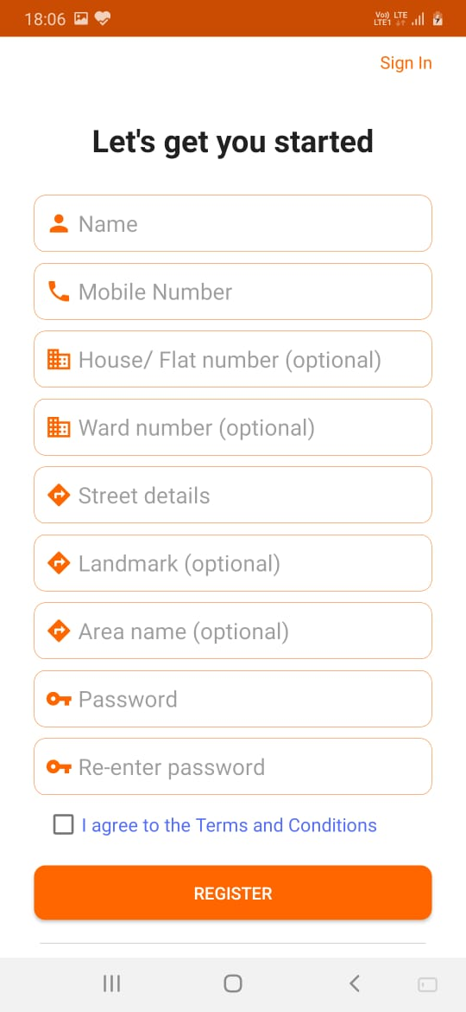

3. **Login page :-**

Mobile number

Password

Forgot password option required.

**Design reference :-**

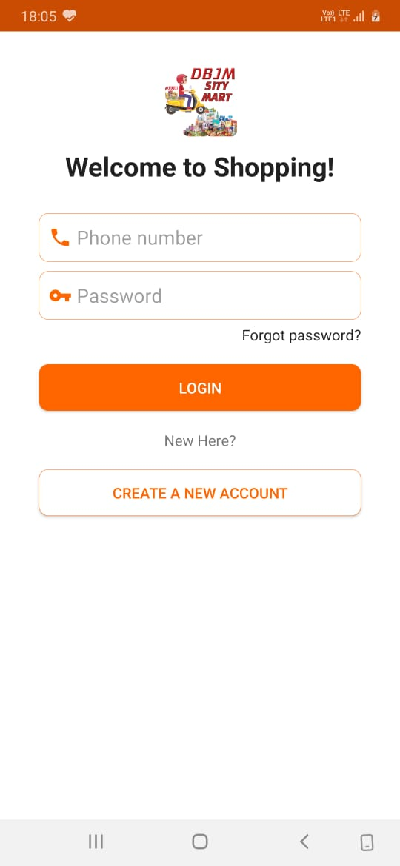

**3. Home page**

Section 1 :-

**Title : TSR COVID 19 CENTER (HOTEL)**

**5 Days Package :-**

Includes :-

* Room rent
* 3 meals
* Doctor & nurse visit once a day

**7 days Package :-**

Includes :-

* Room rent
* 3 meals
* Doctor & nurse visit once a day

**10 Days Package :-**

Includes :-

* Room rent
* 3 meals
* Doctor & nurse visit once a day

Exclusion for all the packages.

* Pharmacy items (Door delivery)
* Lab & Radiology tests
* Extra food delivery.
* Charges for video consultation with TSR COVID 19 Specialist

**Terms & Conditions :-**

* 100% advance to be paid at the hospital before check in.
* Patients shall be transferred to hospital based on the medical condition subject to availability of foods.
* No refund under any circumstances.
* Attenders not allowed.

Section 2 :-

**Title :- HOME QUARANTINE PROGRAM**

Under the above title, following information to be displayed in a simple and attractive manner.

TSR HEART CARE & DIAGNOSTICS, BANGALORE INTRODUCES

Home Quarantine Package for COVID 19 Patients.

(Asymptomatic & mildly symptomatic patients)

App based self-monitoring of temperature & other symptoms.

Tele-assistance on home isolation protocols.

Video consultation with doctor on 7th and 15 days +2 additional video consults.

Consultation with a clinical psychologist.

Consultation with a dietician.

Consultation with tele-rehabilitation specialist.

24/7 medical assistance available to monitor symptoms on demand.

24/7 Covid 19 helpline available.

Section 3 :-

**Title :- COVID HOMECARE KIT**

* Home sample collection
* Additional tele- consultation
* Additional counselling sessions
* Includes Pulse oximeter | Digital thermometer |N95 masks
* Examination Gloves|Vitamin C|Paracetamol|Sinarest

**Note :-** Some products will be displayed in this section. Users will book the products through UPI Payment.

4. **Slot booking page :-**

Here users will book the slot by selecting any 3 packages below.

5 Days Package

7 Days Package

10 Days Package

After selecting any package, the following form should open.

Name

Mobile number

Address field 1

Address field 2

No of people

Submit button

These bookings will be displayed in the admin app under the slot bookings section.

5. **Caller menu**

Integrate the number +91 9964906768. It should open a dialer on the mobile.

**Sider bar menus :-**

6. **Profile**

Users can update the profile using the following form.

Name

Mobile number

Password

Profile picture

7. **About us :-**

TSR Heart Care & Diagnostics Providing the COVID 19 Services in the Bengaluru city. We have different packages with slot booking systems. Also we provide Home quarantine services with 24/7 teleconference support. 24/7 medical assistance available to monitor symptoms on demand.We also provide home quarantine kits for the users and can buy through online by making online payment.

8. **Our Products :-**

Here list of products will be displayed added by admin. After seeing the products, users can select quantity and book through online via UPI payment.

**Design reference :-**

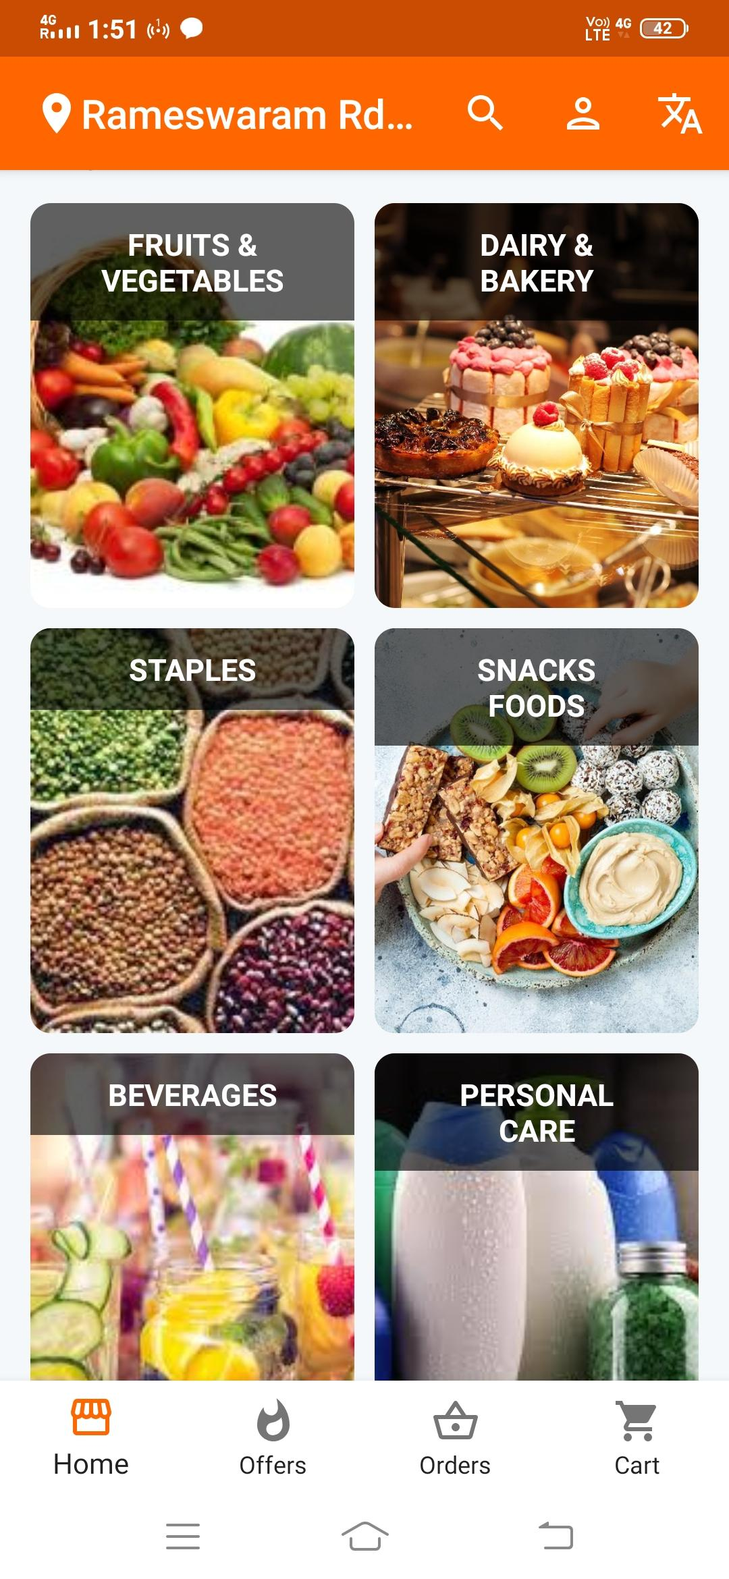

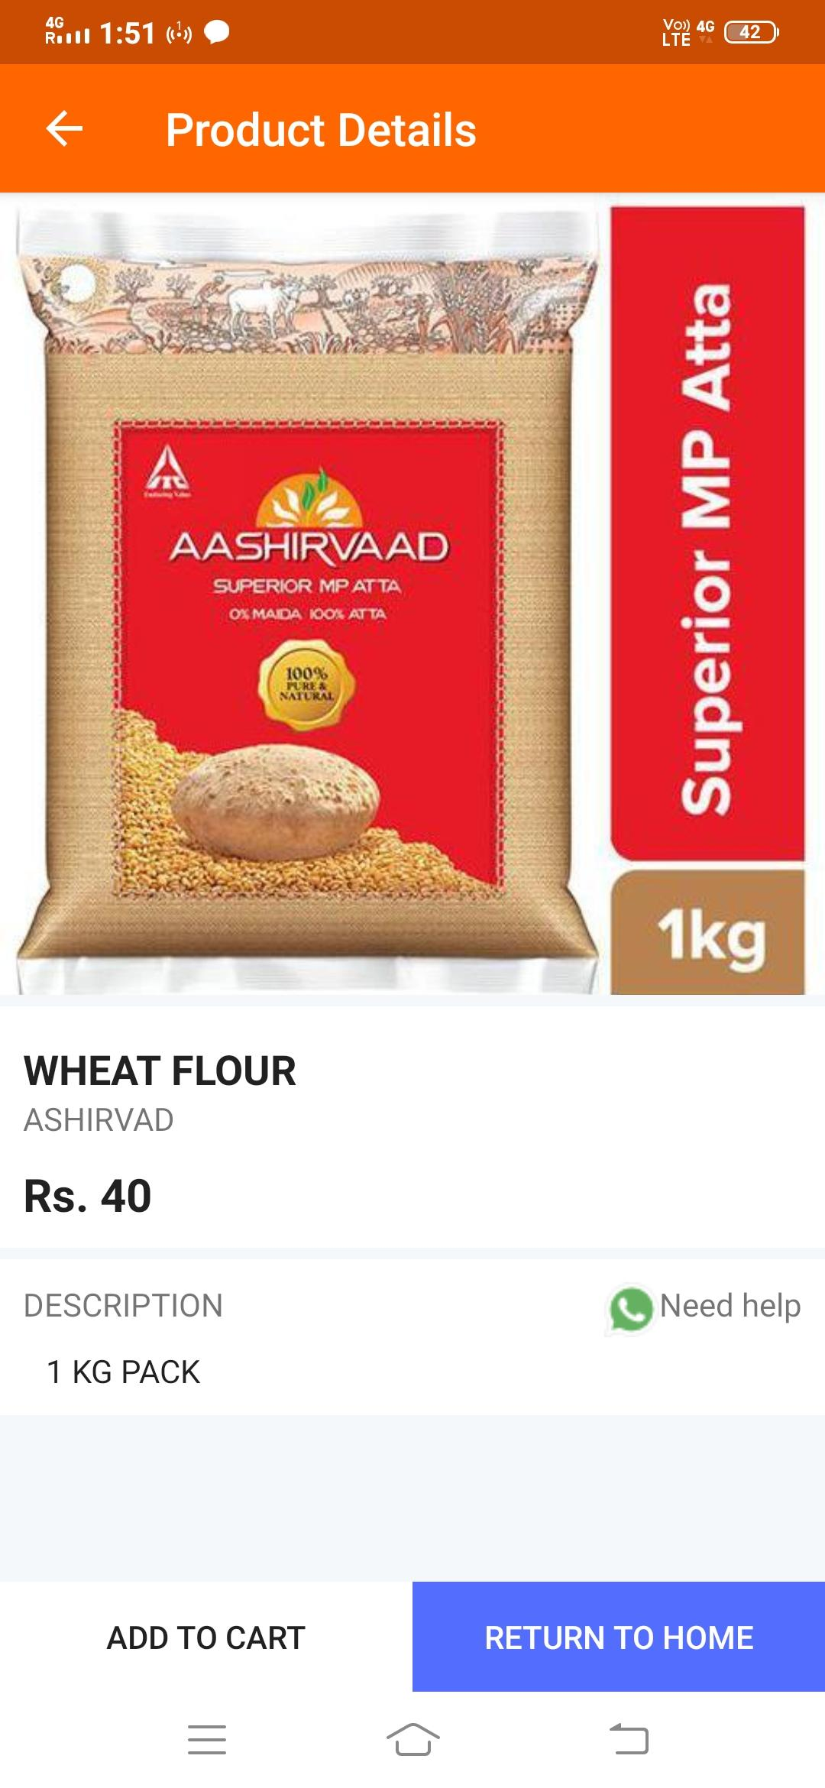

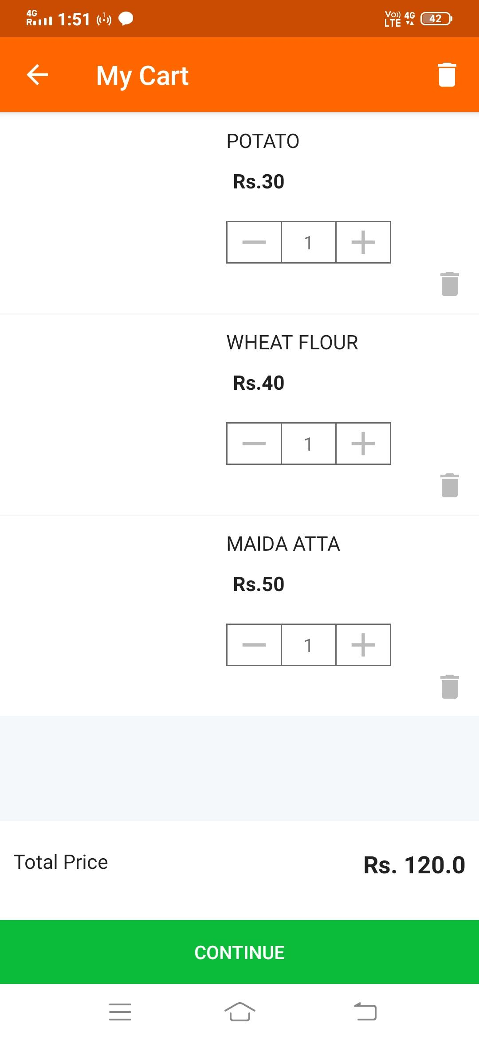

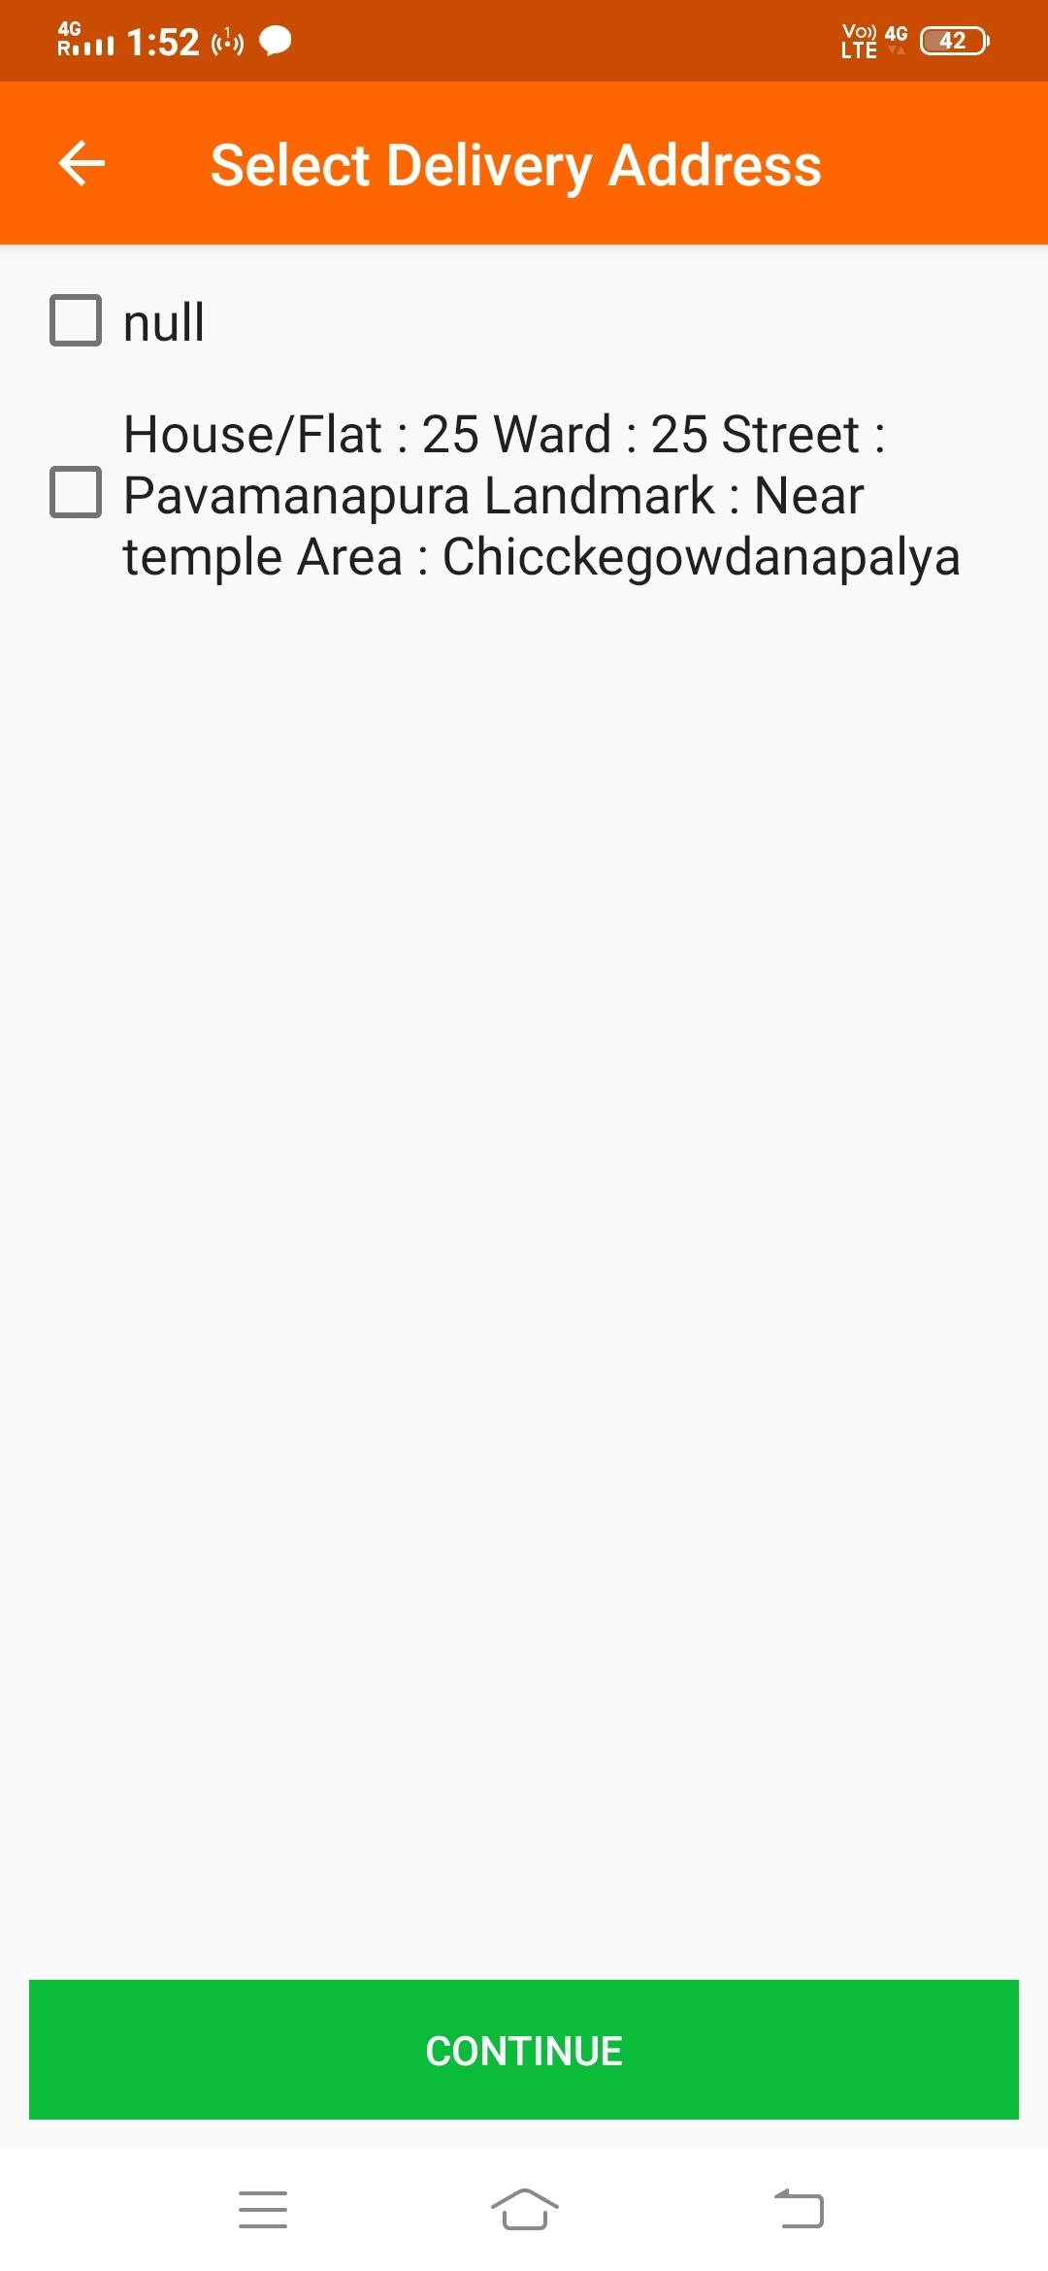

9. **Help center :-**

Following text to be displayed on this page. Keep essential icons.

For any queries, Please contact

+91 6302362937

[cvamsik5@gmail.com](mailto:cvamsik5@gmail.com)

10. **Updates :-**

Here any updates posted by admin will display here.

11. **Contact us :-**

TSR Heart Care & Diagnostics

Dr. T Sashidhar Reddy

M.B.B.S, PGDCC

HSR Layout, Bengaluru

+91 9964906768

12. Share app and logout options required.